**Davies Lab RNAseq Protocol:**

**RNA Isolation using RNAqueous Micro-kit:**

1. Material Preparation:
2. Obtain ice and kit from fridge. Place samples on ice to thaw.

1. Check to make sure there is a check mark on Wash Solution 1 and Wash Solution 2/3 and that there is a date on the box indicating when EtOH was added.

* If opening a new kit, 10.5 mL of 100% ethanol must be added to Wash Solution 1 and 22.4 mL to Wash Solution 2/3, and the date it was added must be labeled on the box.
* This should be done by graduate students, post docs, or Sarah ONLY.

1. Make sure there is enough elution solution for your samples (15 µl per sample), and if not, add more to the aliquot or create a new aliquot. Heat the aliquot to 75 °C.
2. Label bead blast tubes, 3 sets of 1.5 mL tubes, and Microfilter Cartridge tubes equal to the number of samples being extracted.

* For example, if extracting 8 samples you would label 8 bead blast tubes, 24 1.5 mL tubes, and 8 Microfilter Cartridge tubes.

1. Sample Preparation: Bead-Beating Method
2. Fill the bottom cone of the bead blast tube minimally with Sigma Glass Beads G1145.
3. Add 150 µL of lysis buffer to each bead blast tube and set tubes in ice.
4. Using sterilized tweezers, pull out sample fragments and add them to the bead blast tubes containing beads and buffer.
   1. If samples are too small to use tweezers (i.e. larvae) centrifuge the sample down for a minute or so on the minifuge and then dump out the supernatant. Cut the very end off of a pipette tip and use this to reconstitute the sample in the remaining ethanol. transfer this to the bead blast tubes. If some sample remains stuck to the tube sides, add a little more ethanol to loosen and then transfer this extra to the bead blast tubes.
5. Place tubes in bead blaster and beat at 5 m/s for 30 seconds. Do this twice.
6. Place tubes in centrifuge for 1 minute at a speed of 16.5 xg. If really foamy, centrifuge for an additional minute or two. If still foamy tap down on bench until foam settles and centrifuge for an additional minute.
7. Transfer everything to one of the labeled 1.5 mL tubes, recording the recovered volumes. Beads and coral fragments should remain in the bead blast tube. Discard bead blast tubes.
   1. Be careful because the beads don’t really pellet!
   2. If you see a “slime” in your sample, be sure to avoid as it can clog the filters
8. Centrifuge 1.5 mL tubes for two minutes at 16.5 xg. Transfer supernatant liquid to another set of labeled 1.5 mL tubes, avoiding any beads remaining and notating how much volume is recovered. Discard of the first set of 1.5 mL tubes.
9. Determine what was the highest volume recovered of supernatant. Calculate what half of that volume is.
10. Sample Preparation: Incubation Method
11. Add 150 µL of lysis buffer to each sample tube and thoroughly back-pipette. Vortex tubes and then let them sit for 15 minutes at room temperature. Vortex again and let sit for another 15 minutes.
12. Place tubes in centrifuge for 1 minute at a speed of 16.5 xg. If really foamy, centrifuge for an additional minute or two. If still foamy tap down on bench until foam settles and centrifuge for an additional minute.
13. Transfer everything to one of the labeled 1.5 mL tubes, recording the recovered volumes. Coral fragments should remain in the sample tubes. Discard the sample tubes
    1. If you see a “slime” in your sample, be sure to avoid as it can clog the filters
14. Centrifuge 1.5 mL tubes for two minutes at 16.5 xg. Transfer supernatant liquid to another set of labeled 1.5 mL tubes, avoiding any beads remaining and notating how much volume is recovered. Discard of the first set of 1.5 mL tubes.
15. Determine what was the highest volume recovered of supernatant. Calculate what half of that volume is.
16. RNA Isolation
17. Add 100% ethanol equal to the calculated value to all of your tubes containing supernatant, making sure to back-pipette to mix the solution. Pipette the mixture onto the Microfilter Cartridge tubes. Discard of your second set of 1.5 mL tubes.
18. Centrifuge for 1 minute at 16.5 xg so all the mixture passes through the filter.
19. Open the Microfilter Cartridge of all your samples and add 180 µL of Wash Solution 1 to the filter. Close the cap and centrifuge again for 1 minute. Empty the collection tube.
20. Add 180 µL of Wash Solution 2/3 to the filter and centrifuge for 1 minute. Add another 180 µL of Wash Solution 2/3 to the filter and centrifuge once more for 1 minute. Empty the collection tube.
21. Centrifuge for 2 minutes to dry the filter.
22. Open the tubes and place them in ice. Place a kimwipe over them and let them air dry for 2 minutes. Transfer the filter cartridges to your final set of 1.5 mL tubes and close them to prevent further drying.
23. Add 15 µL of pre-heated Elution Solution to the center of the filter. Close cap and let samples sit for 1 minute. Centrifuge at 16.5 xg for 1 minute. Repeat, adding the same 15 µL of Elution Solution back to the filter, letting the samples sit, and centrifuging for 1 minute.
    1. be sure to add the elution solution directly to the filter; make sure none is left on the sides
24. Continue with DNAsing for the Micro kit or store samples in the -80 °C.

**Protocol for DNasing with the RNAqueous-Micro Kit**

**Before Beginning**

* Put the 10X DNase I Buffer and the DNase Inactivation Reagent (bead slurry) on ice to thaw
* Transfer your eluted RNA into sterile, clearly labeled 0.5 ml tubes
* Heat either a heat block or a water bath to 37 °C

1. **If working with more than ~4 samples, prepare a master mix**
   * For each sample, you will need 1/10 of your RNA volume of 10X DNase I Buffer. For example, if you are working with RNA eluted in 20 µl, you will need 2 µl of 10X buffer for each sample
   * For each sample, you will also need 1 µl of DNase I (pulled from freezer when ready)
     1. Flick the enzyme to mix it well
     2. Pipette ***SLOWLY***
   * Always prepare a master mix that has slightly more volume than you actually need to account for evaporation and loss to the exterior of the pipette tips
   * When you add from the master mix to each sample, back-pipette gently to the first stop several times to ensure all of the mix was ejected; then, eject to the second stop
2. **If ≤ 4 samples**
   * When you add the 10X DNase I Buffer, eject into the sample liquid
   * When you add the enzyme, back-pipette slowly to the first stop several times to ensure all of the enzyme was ejected; then, eject to the second stop
3. **Incubate the reaction at 37 °C for 30 minutes**
   * This can either be done in the water bath or the heat block, even without adapters
4. **Add the DNase Inactivation Reagent** 
   * Vortex the DNase Inactivation Reagent (bead slurry) to ensure an even suspension of the microscopic inactivation beads
   * Add 2 µl OR 1/10 RNA volume to each sample, whichever is greater (2 µl for 20 µl RNA eluate)
   * Eject into the sample; you will see the inactivation reagent sink to the bottom of the tube
   * After adding to each tube, gently flick to mix, then tap on the bench to remove from the walls of the tube (rather than spinning)
   * Wait 1 minute at RT
   * Flick again, tap down again, wait 1 minute at RT again
5. **Spin down the beads and transfer the DNased RNA**
   * Centrifuge for 2 minutes at max speed to pellet the beads in the bottom of the tube
   * Carefully pipette out the DNased RNA on top of the beads; try to recover as much as possible
   * For a 20 µl RNA volume, the final volume in the tube at this stage should be 25 µl; try to recover ~21-22 µl
   * Transfer to a final, labeled tube that includes “DNased” somewhere

**Normalizing After DNAsing:**

1. After obtaining DNAsed concentrations, use the concentrations and volume of available RNA to determine how much total RNA you have per sample.
2. Determine whether you have at least 1 µg of total RNA for each sample. For the samples you do not have at least 1 µg of but do have more un-extracted RNA re-extraction should probably be attempted. Once 1 µg is attained for each sample, determine what volume of DNAsed RNA and what volume of water must be added together to yield an 11 µL mixture containing 1 µg. For samples close to 1 µg a dilution may not be necessary and instead speed vacuuming the samples until they reach a volume of 11-13 µL may be a better option. If so, no water would be added to obtain the desired 11 µL. For samples far surpassing 1 µg, a dilution is likely the best option.
3. After speed vacuuming the samples that require it, transfer the calculated volume of DNAsed RNA needed to yield an 11 µL mixture onto a 96 well plate, keeping track of which sample goes into which well. Add milli-Q water to the samples that need to be diluted. Tap the plate down to mix and get any liquid on the sides of the well into the center of the well.
4. Label the plate and make sure that on it is written “Normalized”. The plate can be sealed and stored in the -80 °C or can now be used for first strand cDNA synthesis.

**First Strand cDNA Synthesis:**

1. Place DNTP (10 mM) (white cap, common reagents), DTT (green cap, common reagents), 5X First strand buffer (red cap, common reagents), and 3ILL-30TV (10 µM) (last aliquot/dilution in 1.5 mL tube in personal box, undiluted in blue capped tube in TagSeq box) on ice to thaw (all found in the -20 °C). If the normalized plate is in the -80 °C also place it on ice to thaw and spin it down once thawed.
2. For each sample, the following are necessary:

* 1.0 µL DNTP (10mM)
* 2.0 µL DTT
* 4.0 µL 5X First strand buffer
* 1.0 µL 3ILL-30TV (10 µM)

Create a master mix, combining enough of the reagents for all of your samples plus an additional 0.5 samples. For example, if you have 8 samples, you would multiply the values above by 8.5 to create your master mix. Flick the tube containing your master mix and spin down for 1 second.

Before running all slamples through first strand cDNA synthesis, we want to first test of a small subset of samples with a non-reverse transcriptase (RT) control. For this, create enough master mix for double your samples. Each sample will be used for a positive (RT test) and negative (non RT control) test. Label half the tubes with a (+) and the other half with a (-).

1. Add 8.0 µL of the master mix to each of the wells in your normalized plate, making sure to back pipette several times. A multi-channel may be useful if working with a lot of samples.
2. Incubate the plate in the PCR thermocycler at 70 °C for 10 minutes (“heatdegrade”).
3. While the incubation is going on: obtain “RNA ‘sw’ oligos” (10 µM), also known as switch primer, from the -80 °C (most recent aliquot/dilution in 1.5 mL tube; undiluted in white capped tube, both in personal box [rack 1A, Oculina extracted box]) and SMARTScribe Reverse Transcriptase (RT) from the -20 °C (light blue cap in black enzyme box) and allow them to thaw. Create a master mix of these two reagents. You will need 1 µL of switch primer and 1 µL of RT for every sample. Add enough reagent to the master mix for each of your samples plus an additional 1 sample (the mix can get bubbly!). Flick the tube containing your master mix and spin down for 1 second. Place the tube on ice.

*For the first non-RT test of a subset pf samples, only put this mastermix in the (+) tubes. The (-) tubes only receive 1 µL of switch primer.*

Note: The switch oligo is sensitive and easily degraded. Always handle with gloves and keep on ice once thawed.

1. Transfer your plate after it is done with the heat degradation to ice for 2 minutes. Add 2 µL of the switch primer-RT master mix to each well, making sure to back pipette ~10x and eject everything back into the tube.
2. Incubate the plate in the PCR thermocycler at 42 °C for 1 hour and then at 65 °C for 15 minutes (“cDNA1”). Be sure to put the RNA sw oligos in the -80 oC ASAP.
3. The plate with the synthesized first strand cDNA can now be stored in the -20 °C or used immediately for cDNA amplification.

**cDNA Amplification Test:**

1. Place DNTP (2.5 mM), 10X PCR buffer, 3ILL-30TV (10 µM), and 5ILL (10 µM) on ice to thaw (all found in the -20 °C). If the cDNA plate is in the -20 °C also place it on ice to thaw and spin it down once thawed. You will also need Titanium Taq, which is also found in the -20 °C, but it should remain in the freezer or kept on ice until just before you need to use it. It does not require thawing.
2. Note that you should only test-amplify a random set of your samples to verify that everything is working as anticipated. For each sample you are test-amplifying, the following are necessary:

* 12.8 µL molecular grade water
* 2.0 µL DNTP (2.5 mM)
* 2.0 µL 10X PCR buffer
* 0.5 µL 3ILL-30TV (10 µM)
* 0.5 µL 5ILL (10 µM)
* 0.2 µL Titanium Taq (TitTaq)

Create a master mix, combining enough of the reagents for all of your samples plus an additional 0.5 samples. For example, if you have 8 samples, you would multiply the values above by 8.5 to create your master mix. Flick the tube containing your master mix and spin down for 1 second.

1. Obtain a new 96 well plate and label it “Amp Test”. Add 18.0 µL of the master mix to each of your sample wells. Transfer 2.0 µL of your cDNA from the cDNA plate to the new plate, making sure to back pipette several times. A multi-channel may be useful if working with a lot of samples.
2. Incubate the plate in the PCR thermocycler at 95 °C for 5 minutes and then for 18 cycles of 95 °C for 1 minute, 63 °C for 2 minutes, and 72 °C for 2 minutes (“cDNA PCR”).
3. The amplified cDNA can now be stored in the -20 °C. To test for amplification, run a 1% agarose gel with 2-5 µL of each. If the amplification test was successful, you can move forward with a full amplification with your cDNA plate.

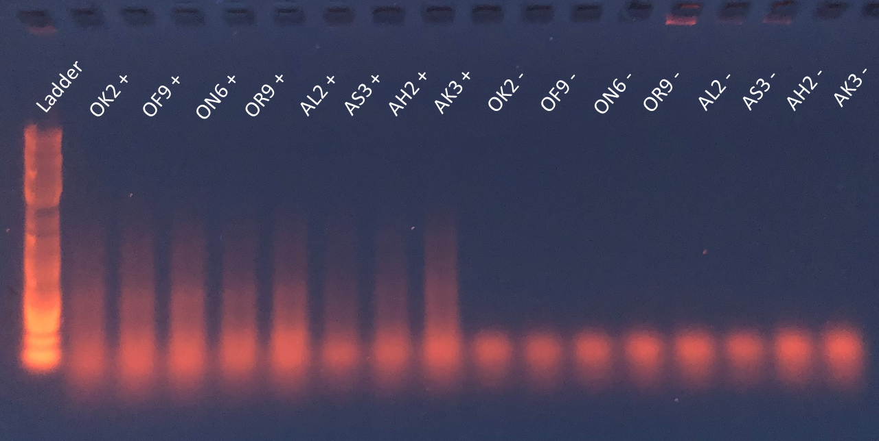

cDNA Test: Positive controls show a bright smear of DNA while negative controls do not

**cDNA Amplification:**

Follows similar protocol to the cDNA Amplification Test. Changes are bolded.

1. Place DNTP (2.5 mM), 10X PCR buffer, 3ILL-30TV (10 µM), and 5ILL (10 µM) on ice to thaw (all found in the -20 °C). If the cDNA plate is in the -20 °C also place it on ice to thaw and spin it down once thawed. You will also need Titanium Taq, which is also found in the -20 °C, but it should remain in the freezer or on ice until just before you need to use it. It does not require thawing.
2. For each sample, the following are necessary:

* **4.8 µL molecular grade water**
* 2.0 µL DNTP (2.5 mM)
* 2.0 µL 10X PCR buffer
* 0.5 µL 3ILL-30TV (10 µM)
* 0.5 µL 5ILL (10 µM)
* 0.2 µL Titanium Taq (TitTaq)

Create a master mix, combining enough of the reagents for all of your samples plus an additional 0.5 samples. For example, if you have 8 samples, you would multiply the values above by 8.5 to create your master mix. Flick the tube containing your master mix and spin down for 1 second.

1. Obtain a new 96 well plate and label it “**Amp cDNA**”. Add **10.0 µL of the master mix** to each of your sample wells. Transfer **10.0 µL of your cDNA** from the cDNA plate to the new plate, making sure to back pipette several times. A multi-channel may be useful if working with a lot of samples.
2. Incubate the plate in the PCR thermocycler at 95 °C for 5 minutes and then for 18 cycles of 95 °C for 1 minute, 63 °C for 2 minutes, and 72 °C for 2 minutes (“cDNA PCR”).
3. The amplified cDNA can now be stored in the -20 °C.

**Purification:**

1. Obtain AMPure Beads from the fridge (brown liquid), a 96 Super Magnet Plate, a new 96 well plate labeled “Cleaned”, 400 µL of 70% ethanol per sample (slightly more for pipetting error), and the amplified cDNA plate, which should be spun down, especially if taken from the -20 °C and thawed.

Note: to avoid over-drying the beads, it is best to clean only one column at a time. Keep other samples you are not cleaning on ice.

1. Mix the AMPure Beads bottle (invert until there is no darkness on the bottom) and add 36 µL of the beads to each of the sample wells in the amplified cDNA plate (assuming that your amplified cDNA volume is 20 µL), making sure to thoroughly pipette (~10 back pipettes).

* If the amplified cDNA volume is not 20 µL, you can determine the volume of beads added to each sample by multiplying the cDNA volume by 1.8.

1. Let the mixed samples incubate for 5 minutes. Place the reaction plate onto the 96 Super Magnet Plate for 2 minutes.
2. With the reaction plate still on the magnetic plate, pipette out and discard the resulting clear solution from each well, leaving behind 5 µL of supernatant. If you started with 20 µL of cDNA and added 36 µL of the beads, you should remove 51 µL and leave 5 µL, for example.
3. Add 200 µL of 70% ethanol to each well of the reaction plate and incubate for 30 seconds. Pipette and discard all of the ethanol in the wells, including the 5 µL left before (205 µL total). Repeat, adding another wash of 200 µL of 70% ethanol, incubating for 30 seconds, and discarding the ethanol.
4. Place the reaction plate, while still on the magnetic plate, in the fume hood for 1-2 minutes to dry the beads and get rid of any ethanol traces.
5. Remove the reaction plate from the magnetic plate and add 25 µL of molecular grade water to each well, back-pipetting at least 10 times to mix. Your beads should be dissolved and you should have brown solutions. If any beads stick to the sides, they probably became over-dried. You can scrape them with a pipette tip and/or continue to back-pipette until they dissolve. Incubate for 2 minutes.
6. Place the reaction plate onto the magnetic plate once more for 2 minutes.
7. Transfer the clear liquid to the newly labeled 96 well plate. You should be able to pipette approximately 22 µL without pulling up beads. Put a Kimwipe behind the pipette tips to check for any trace of beads as you are pipetting. This plate can be stored in the -20 °C.

**Pico-Green Assay:**

Note: Pico Green is light sensitive. Keep covered.

1. Make a working stock of 1x TE (20x TE lives in the fridge - small plastic vial, white cap, on the left side, second shelf).

*Dilute to make fresh 1x TE: See the 1xTE calculator spreadsheet in the drive*

Use a 15 or 50 mL conical (shelves above PCR machine)

1. Prepare the standards: label a set of PCR strip tubes A-H.
2. Add 100 µL 1x TE buffer to B-H.
3. Add 200 µL of 20 ng/µL lambda DNA (in common reagents box) into A.

For easy reference:

|  |  |  |  |  |  |  |  |  |
| --- | --- | --- | --- | --- | --- | --- | --- | --- |
| Tube | A | B | C | D | E | F | G | H |
| 1x TE (µL) |  | 100 | 100 | 100 | 100 | 100 | 100 | 100 |
| 20ng/µLLamda (µL) | 200 | 0 |  |  |  |  |  |  |

1. Use a serial dilution to complete the curve by taking 100 µL from A, mixing it into B via back-pipetting, taking 100 µL from B, mixing it into C, and so on. **STOP** before H, and discard the excess 100 µL. Do not continue the dilution through H because **H is your blank**. The strip tube should have 100 µL volume per tube.

The concentrations of your standards should now be as follows:

|  |  |
| --- | --- |
| **Well** | **[λ] in strip tube (ng/µL)** |
| A | 20 |
| B | 10 |
| C | 5 |
| D | 2.5 |
| E | 1.25 |
| F | 0.625 |
| G | 0.3125 |
| H | 0 |

1. Because diluting the standards is tricky, you should run one test with just the standards first, this way you don’t waste reagents to later find out your standard curve is not usable.
2. Create a master mix just for your standards, combining the Pico Green reagent (in enzyme box in -20°C freezer) and 1x TE as follows:
   * 1. First thaw the pico green reagent. PUT FOIL OVER IT as it is light sensitive.
     2. It can take a long time to thaw and sometimes remains somewhat crystalline. It’s fine to briefly heat it at 37 °C in the heat block to liquify it
     3. Vortex once thawed
     4. Wrap a conical vial in foil for your master mix
     5. Add 845.75 µL of 1X TE and 4.25 µL of Pico Green reagent
     6. Vortex and keep in the dark (put in drawer while you set up)
     7. Leave pico reagent in drawer as you’ll need it again shortly

1. Grab a NEW black plate from the shelf above the plate reader. These are expensive so try to run as many samples as possible to maximize their use. Ask your lab mates if they need to assay any samples and combine samples onto one plate after the standard curve is verified to be usable.
2. Add 100 µL of 1x TE buffer to 8 wells (A1-H1)
3. Add 2 µL of each standard to each well. Make sure there aren’t bubbles or splashes in the wells
4. Add 98 µL of the master mix (7.v) to each well, again ensuring there are no bubbles or splashes in the wells.
5. Incubate for 5 minutes IN THE DARK (place in box, or drawer)
6. In the meantime set up the plate reader
   1. Turn on computer and open plate reader software
   2. Open the pico green assay file (Excitation should be at 480 nm and emission at 520 nm).
   3. Go to plate template and designate A1-G1 as standards with the concentrations listed above, with a 1/2 dilution factor starting with the concentration in A1 and then H1 as a blank
7. Place the plate in the plate reader, lining up well A1 with the corner of the plate reader labeled A1 and press run
8. Use the standard curve equation to calculate your standard curve accuracy. Use the google sheet in Pico Assay folder on lab drive
9. If your R2 was > 0.98 then you can proceed to quantify your samples. Otherwise make a new set of standards and try again (you will need to make more 1xTE if your standards are off)
10. Create a master mix just for your standards and samples, combining the Pico Green reagent (in enzyme box in freezer) and 1x TE as follows:
    * 1. Wrap a conical vial in foil for your master mix (you can use the same conical as before)
      2. Add 99.5*(#of samples+0.5) µL of 1X TE and 0.5*(#of samples+0.5) µL of Pico Green reagent
      3. Vortex and keep in the dark (put in drawer while you set up)
11. Add 100 µL of 1x TE buffer to wells
    1. If running a lot of samples, it may be easiest to put the buffer in a reagent reservoir and use a multichannel to pipette into each well
12. Add 2 µL of each standard to wells A2-H2. Then add 2 ul of your samples to each respective well. Make sure there aren’t bubbles or splashes in the wells
13. Add 98 µL of the master mix to the wells, again making sure there are not bubbles or splashes.
    1. If running a lot of samples, it may be easiest to put the mastermix in a reagent reservoir and use a multichannel to pipette into each well. If you do so, be sure to cover the top with foil when you aren’t drawing from it.
14. Incubate for 5 minutes IN THE DARK (place in box, or drawer)
15. Measure with plate reader and use google sheet to get your concentrations :)
    1. Double check your standard curve to make sure the R2 value is greater than 0.98.

**Normalizing After Purification:**

1. After obtaining Pico concentrations, determine what the lowest concentrated sample is and how much volume of it there is. Determine how much template and molecular grade water must be combined for all other samples to attain the same concentration and volume as the sample with the lowest concentration.
2. Label a new 96 well plate with “Normalized”. Add the calculated amounts of template (from the “Cleaned” plate) and water so that all samples have the same concentration, and if possible, also the same volume. Back-pipette to mix the water and template.
3. This plate may be stored in the -20 °C or used immediately for barcoding.

**Barcoding Test:**

1. Place DNTP (2.5 mM), 10X PCR buffer, one of the four 10 mM Truseq F-primers (1, 2, 3, or 4), and 4 different reverse-barcodes (R-BC) on ice to thaw (all found in the -20 °C). If the Normalized plate is in the -20 °C also place it on ice to thaw and spin it down once thawed. You will also need Titanium Taq, which is also found in the -20 °C, but it should remain in the freezer or kept on ice until just before you need to use it. It does not require thawing.
2. For each sample, the following are necessary:

* 15.2 µL molecular grade water
* 3.0 µL DNTP (2.5 mM)
* 3.0 µL 10X PCR buffer
* 0.6 µL TruSeq (1, 2, 3, or 4) (10 µM)
* 0.2 µL Titanium Taq (TitTaq)

Create a master mix, combining enough of the reagents for 4 of your samples plus an additional 0.3 samples. You should multiply the values above by 4.3 to create your master mix. Flick the tube containing your master mix and spin down for 1 second.

1. Choose 4 of your samples to do the barcoding test with (4 samples with the highest volumes if your volumes are not equal). Label 4 strip PCR tubes with your sample names and add 22 µL of master mix to each one. Add 6 µL of a 1 µM barcode (R-BC) to each tube. Each tube should receive a different barcode. Add 2 µL of your chosen samples from the Normalized plate to the PCR tubes. You should have a total of 30 µL per PCR tube. Make a note that your normalized plate has 2 µL less for the 4 chosen samples.
2. Incubate the 4 PCR tubes in the PCR thermocycler at 95 °C for 5 minutes and then for 6 cycles of 95 °C for 40 seconds, 63 °C for 2 minutes, and 72 °C for 1 minute (“barcoding”).
3. Run a 1.5% gel with 5 µL of your samples and 3 µL of ladder to verify that barcoding was successful. If successful, create a sheet in which every sample has a barcode and a TruSeq F-primer. Samples can have the same barcode or same Truseq F-primer but no two samples should have both be the same. Proceed to barcode all your samples.

**Barcoding:**

Follows similar protocol to the Barcoding Test.

**Note: Between 6 and 10 µL of amplified product should go into barcoding. You will use closer to 10 if your amplifications were inefficient/low concentrations. Consult Sarah.**

1. Place DNTP (2.5 mM), 10X PCR buffer, the 10 mM Truseq F-primers (1, 2, 3, and 4) needed, and all the different reverse-barcodes (R-BC) to be used on ice to thaw (all found in the -20 °C). If the Normalized plate is in the -20 °C also place it on ice to thaw and spin it down once thawed. You will also need Titanium Taq, which is also found in the -20 °C, but it should remain in the freezer or kept on ice until just before you need to use it. It does not require thawing.
2. For each TruSeq Uni master mix, the following are necessary (per sample receiving a given TruSeq F-primer):

* 7.2 µL molecular grade water
* 3.0 µL DNTP (2.5 mM)
* 3.0 µL 10X PCR buffer
* 0.6 µL TruSeq (10 µM)
* 0.2 µL Titanium Taq (TitTaq)

Create a master mix, combining enough of the reagents for all of your samples plus an additional sample. For example, if you have 34 samples, you would multiply the values above by 35 to create your master mix. Flick the tube containing your master mix and spin down for 1 second.

1. Label a new 96 well plate with “Barcoded” and add 14 µL of master mix to each one. Add 6 µL of R-BC to each sample. **Each sample should receive a different F-primer + reverse-barcode combination.** Add 10 µL* (6-10 µL depending on amplified product concentrations—adjust amount of molecular grade water in MM as needed) of your samples from the Normalized plate to the Barcoding plate. You should have a total of 30 µL in each well.
2. Incubate the 4 PCR tubes in the PCR thermocycler at 95 °C for 5 minutes and then for 6 cycles of 95 °C for 40 seconds, 63 °C for 2 minutes, and 72 °C for 1 minute (“barcoding”).
3. Run a gel with 5 µL of your samples and 1 µL of ladder. To create a large gel, you would use 150 mL of buffer, 2.25 g of agarose, and 4 µL of GelRed. Verify that all your barcoded samples have the same amount of smearing and intensity.
4. The barcoded plate can be stored in the -20 °C.

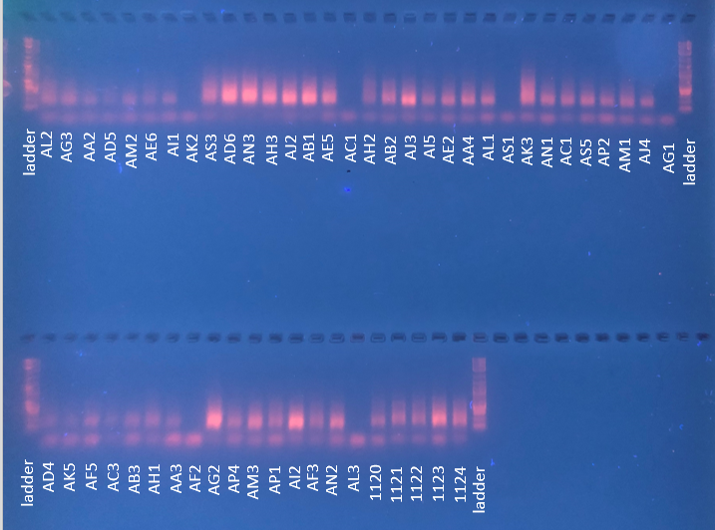

Successfully barcoded samples have a smear in their lane. Unsuccessfully barcoded samples (i.e. AK2, AC1, AS1, AG1, AF2, AL3) do not.

**Pooling Barcoded Samples and Gel Extracting:**

1. Pool 5 µL of all your samples that were successfully barcoded into a single tube. Run the entirety of your pooled samples on two extended lanes (large combs). Use 1-2 µL of loading dye for every 5 µL of sample template. Run the 2% agarose gel dyed with Sybr green at 70 volts for 90 minutes.
2. Once the gel is complete, check to see that there are two large smears. Label two 1.5 mL tubes with what you want the prepped library to be called. Cut the gel with a sterile razor blade along the smear on one of the lanes between 400 and 500 base pairs. Don’t cut all the way to the edge of the smear, only take the center of the gel smear! Using a pipette tip extract that piece of gel from the rest of the lane and add it to one of the 1.5 mL tubes. Repeat with the second lane and second 1.5 mL tube.
3. Add 30 µL of molecular grade water to each tube and place the tubes in the fridge, allowing the desired product to leave the gels overnight. Use a pipette tip to break apart the gel if the gel is not fully submerged in the water.
4. Extract the liquid from the tubes, leaving the gel behind, and place in newly labeled 1.5 mL tubes. These will be your final product.

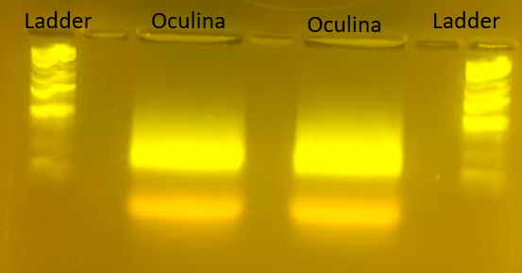

Before extraction.

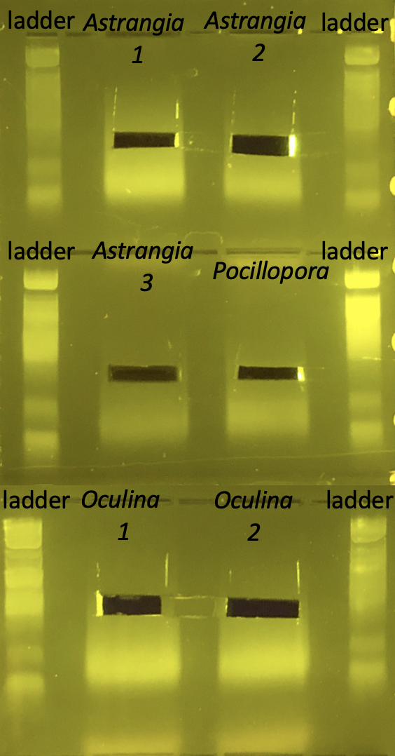

After extraction

**P5/P7 Check:**

1. Place DNTP (2.5 mM), 10X PCR buffer, IC1-P5 primer (10 µM), and IC2-P7 primer (10 µM) on ice to thaw (all found in the -20 °C). Also place the extracted product from the gels on ice. You will also need Titanium Taq, which is also found in the -20 °C, but it should remain in the freezer or kept on ice until just before you need to use it. It does not require thawing.
2. For each sample, the following are necessary:

* 6.4 µL molecular grade water
* 1.0 µL DNTP (2.5 mM)
* 1.0 µL 10X PCR buffer
* 0.2 µL IC1-P5 primer (10 µM)
* 0.2 µL IC2-P7 primer (10 µM)
* 0.2 µL Titanium Taq (TitTaq)

Create a master mix, combining enough of the reagents for all of your samples plus an additional 0.5 samples. If you extracted from two lanes, you should only need to multiply the values above by 2.5 to create your master mix. Flick the tube containing your master mix and spin down for 1 second.

1. Label two strip PCR tubes (if only having two samples) and add 9 µL of master mix to each tube. Add 1 µL of gel-extracted final product to each tube. Flick and spin down for one second.
2. Incubate the 2 tubes in the PCR thermocycler at 95 °C for 5 minutes and then for 12 cycles of 95 °C for 40 seconds, 63 °C for 2 minutes, and 72 °C for 1 minute (“p5/p7”).
3. Run your 3 µL of your samples on a 2% gel using gel red. Verify that the correct size range was extracted from the gel after pooling (400-500 bp).

**Molarity Determination:**

1. Determine what volume you have in each of your final product tubes. Do a Pico Green assay as described before to determine what concentration your products have. To determine the molarity of your products (in nM), use the following equation:

Since the base pair range of interest is 400-500, the median, 450, is used in calculating molarity.